1

Code

**data** prob1;

input (HT1-HT5)(**2.**) (WT1-WT5)(**3.**);

dens1=WT1/HT1\*\***2**;

dens2=WT2/HT2\*\***2**;

dens3=WT3/HT3\*\***2**;

dens4=WT4/HT4\*\***2**;

dens5=WT5/HT5\*\***2**;

datalines;

6862727074150090208230240

64 68 70140 150 170

;

**run**;

/*proc print data=prob1;

run;*/

**data** prob2;

set prob1;

/*Using Arrays for Height Weight Density*/

array a(**5**) HT1-HT5;

array b(**5**) WT1-WT5;

array c(**5**) dens1-dens5;

do i=**1** to **5**;

c(i)=b(i)/a(i)\*\***2**;

end;

drop i;

**run**;

Title 'Prob 1';

**proc** **print** data=prob2;

**run**;

Title;

Log File

206 data prob1;

207 input (HT1-HT5)(2.) (WT1-WT5)(3.);

208 dens1=WT1/HT1**2;

209 dens2=WT2/HT2**2;

210 dens3=WT3/HT3**2;

211 dens4=WT4/HT4**2;

212 dens5=WT5/HT5**2;

213 datalines;

NOTE: Missing values were generated as a result of performing an operation on missing values.

Each place is given by: (Number of times) at (Line):(Column).

1 at 209:12 1 at 209:16 1 at 211:12 1 at 211:16

NOTE: The data set WORK.PROB1 has 2 observations and 15 variables.

NOTE: DATA statement used (Total process time):

real time 0.09 seconds

cpu time 0.04 seconds

216 ;

217 run;

218

219 /*proc print data=prob1;

220 run;*/

221

222

223 data prob2;

224 set prob1;

225 /*Using Arrays for Height Weight Density*/

226 array a(5) HT1-HT5;

227 array b(5) WT1-WT5;

228 array c(5) dens1-dens5;

229 do i=1 to 5;

230 c(i)=b(i)/a(i)**2;

231 end;

232 drop i;

233 run;

NOTE: Missing values were generated as a result of performing an operation on missing values.

Each place is given by: (Number of times) at (Line):(Column).

2 at 230:18 2 at 230:23

NOTE: There were 2 observations read from the data set WORK.PROB1.

NOTE: The data set WORK.PROB2 has 2 observations and 15 variables.

NOTE: DATA statement used (Total process time):

real time 0.07 seconds

cpu time 0.06 seconds

234

235 Title 'Prob 1';

236

237 proc print data=prob2;

238 run;

NOTE: There were 2 observations read from the data set WORK.PROB2.

NOTE: PROCEDURE PRINT used (Total process time):

real time 0.16 seconds

cpu time 0.04 seconds

239

240 Title;

Output

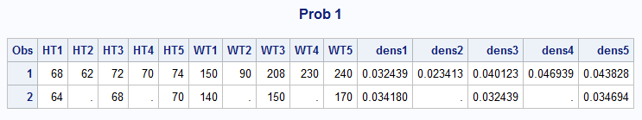

2

Code

**DATA** OLDMISS;

INPUT A B C X1-X3 Y1-Y3;

IF A=**999** then A=**.**;

IF B=**999** then B=**.**;

IF C=**999** then C=**.**;

IF X1=**999** then X1=**.**;

IF X2=**999** then X2=**.**;

IF X3=**999** then X3=**.**;

IF Y1=**999** then Y1=**.**;

IF Y2=**999** then Y2=**.**;

IF Y3=**999** then Y3=**.**;

DATALINES;

1 2 3 4 5 6 7 8 9

999 4 999 999 5 999 777 7 7

;

**run**;

/*proc print data=OLDMISS;

run;*/

**Data** old;

set OLDMISS;

/*Using arrays*/

array d(**3**) A B C;

array e(**3**) X1-X3;

array f(**3**) Y1-Y3;

do i=**1** to **3**;

if d(i)=**999** then d(i)=**.**;

else if e(i)=**999** then e(i)=**.**;

else if f(i)=**999** then f(i)=**.**;

end;

drop i;

**run**;

Title 'OldMiss';

**proc** **print** data=old;

**run**;

Title;

Log File

243 DATA OLDMISS;

244 INPUT A B C X1-X3 Y1-Y3;

245 IF A=999 then A=.;

246 IF B=999 then B=.;

247 IF C=999 then C=.;

248 IF X1=999 then X1=.;

249 IF X2=999 then X2=.;

250 IF X3=999 then X3=.;

251 IF Y1=999 then Y1=.;

252 IF Y2=999 then Y2=.;

253 IF Y3=999 then Y3=.;

254 DATALINES;

NOTE: The data set WORK.OLDMISS has 2 observations and 9 variables.

NOTE: DATA statement used (Total process time):

real time 0.01 seconds

cpu time 0.00 seconds

257 ;

258 run;

259 Data old;

260 set OLDMISS;

261 /*Using arrays*/

262 array d(3) A B C;

263 array e(3) X1-X3;

264 array f(3) Y1-Y3;

265 do i=1 to 3;

266 if d(i)=999 then d(i)=.;

267 else if e(i)=999 then e(i)=.;

268 else if f(i)=999 then f(i)=.;

269 end;

270 drop i;

271 run;

NOTE: There were 2 observations read from the data set WORK.OLDMISS.

NOTE: The data set WORK.OLD has 2 observations and 9 variables.

NOTE: DATA statement used (Total process time):

real time 0.08 seconds

cpu time 0.03 seconds

272

273 Title 'OldMiss';

274

275 proc print data=old;

276 run;

NOTE: There were 2 observations read from the data set WORK.OLD.

NOTE: PROCEDURE PRINT used (Total process time):

real time 0.17 seconds

cpu time 0.01 seconds

277

278 Title;

Output

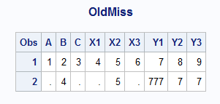

3

Code

**DATA** SPEED;

INPUT X1-X5 Y1-Y3;

DATALINES;

1 2 3 4 5 6 7 8

11 22 33 44 55 66 77 88

;

**run**;

/*proc print data=SPEED;

run;*/

**data** speed2;

set SPEED;

array X(**5**) X1-X5;

array LX(**5**) LX1-LX5;

array Y(**3**) Y1-Y3;

array SY(**3**) SY1-SY3;

Do i=**1** to **5**;

LX(i)=Log(X(i));

end;

drop i;

Do j=**1** to **3**;

SY(j)=SQRT(Y(j));

end;

drop j;

**run**;

Title 'Speed 2';

**proc** **print** data=speed2;

**run**;

Title;

Log File

281 DATA SPEED;

282 INPUT X1-X5 Y1-Y3;

283 DATALINES;

NOTE: The data set WORK.SPEED has 2 observations and 8 variables.

NOTE: DATA statement used (Total process time):

real time 0.06 seconds

cpu time 0.01 seconds

286 ;

287 run;

288 data speed2;

289 set SPEED;

290 array X(5) X1-X5;

291 array LX(5) LX1-LX5;

292 array Y(3) Y1-Y3;

293 array SY(3) SY1-SY3;

294 Do i=1 to 5;

295 LX(i)=Log(X(i));

296 end;

297 drop i;

298 Do j=1 to 3;

299 SY(j)=SQRT(Y(j));

300 end;

301 drop j;

302 run;

NOTE: There were 2 observations read from the data set WORK.SPEED.

NOTE: The data set WORK.SPEED2 has 2 observations and 16 variables.

NOTE: DATA statement used (Total process time):

real time 0.47 seconds

cpu time 0.03 seconds

303

304 Title 'Speed 2';

305

306 proc print data=speed2;

307 run;

NOTE: There were 2 observations read from the data set WORK.SPEED2.

NOTE: PROCEDURE PRINT used (Total process time):

real time 0.13 seconds

cpu time 0.03 seconds

308

309 Title;

Output

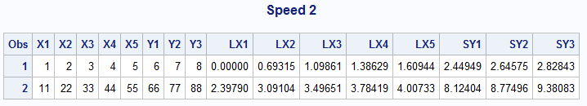

4

/*I have used this data set as given in the mail

01 4 5 5 7 3 1 7 3 6 8

02 8 7 8 6 7 5 4 3 5 6

*/

**DATA** FROG;

INPUT ID X1-X5 Y1-Y5;

DATALINES;

01 4 5 5 7 3 1 7 3 6 8

02 8 7 8 6 7 5 4 3 5 6

;

**run**;

**proc** **print** data=FROG;

**run**;

**data** toad;

set FROG;

array g(**5**) X1-X5;

array h(**5**) Y1-Y5;

/*used cats(concate) to convert numeric to character*/

ID1=cats(**0**||ID);

do Time= **1** to **5**;

X=g(time);

Y=h(time);

output;

end;

keep ID1 Time X Y;

**run**;

Title 'Toad';

**proc** **print** data=toad;

**run**;

Title;

Log File

348 data toad;

349 set FROG;

350 array g(5) X1-X5;

351 array h(5) Y1-Y5;

352 /*used cats(concate) to convert numeric to character*/

353 ID1=cats(0||ID);

354 do Time= 1 to 5;

355 X=g(time);

356 Y=h(time);

357 output;

358 end;

359 keep ID1 Time X Y;

360 run;

NOTE: Numeric values have been converted to character values at the places given by:

(Line):(Column).

353:14 353:17

NOTE: There were 2 observations read from the data set WORK.FROG.

NOTE: The data set WORK.TOAD has 10 observations and 4 variables.

NOTE: DATA statement used (Total process time):

real time 0.10 seconds

cpu time 0.07 seconds

361

362 Title 'Toad';

363

364 proc print data=toad;

365 run;

NOTE: There were 10 observations read from the data set WORK.TOAD.

NOTE: PROCEDURE PRINT used (Total process time):

real time 0.12 seconds

cpu time 0.04 seconds

366

367 Title;

Output

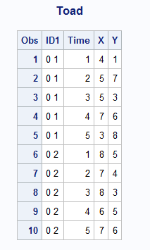

5

Code

**DATA** STATE;

INFORMAT STATE1-STATE5 $2.;

INPUT ID STATE1-STATE5;

DATALINES;

1 NY NJ PA TX GA

2 NJ NY CA XX XX

3 PA XX XX XX XX

;

**run**;

/*proc print data=STATE;

run;*/

**Data** State1;

set state;

array S_array(**5**) STATE1-STATE5;

do i=**1** to **5**;

if S_array(i)='XX' then S_array(i)=" ";

end;

drop i;

**run**;

Title 'State';

**proc** **print** data=State1;

**run**;

Title;

**proc** **transpose** data=State1

out=State2 (rename=(col1=State) drop=_name_);

by ID;

var STATE1-STATE5;

**run**;

/*proc print data=State2;

run;*/

**PROC** **FREQ** DATA=State2 order=freq;

TABLES State*ID / nocum nopercent norow nocol;

**RUN**;

Log File

866 DATA STATE;

867 INFORMAT STATE1-STATE5 $2.;

868 INPUT ID STATE1-STATE5;

869 DATALINES;

NOTE: The data set WORK.STATE has 3 observations and 6 variables.

NOTE: DATA statement used (Total process time):

real time 0.01 seconds

cpu time 0.01 seconds

873 ;

874 run;

875

876 /*proc print data=STATE;

877 run;*/

878

879 Data State1;

880 set state;

881 array S_array(5) STATE1-STATE5;

882 do i=1 to 5;

883 if S_array(i)='XX' then S_array(i)=" ";

884 end;

885 drop i;

886 run;

NOTE: There were 3 observations read from the data set WORK.STATE.

NOTE: The data set WORK.STATE1 has 3 observations and 6 variables.

NOTE: DATA statement used (Total process time):

real time 0.01 seconds

cpu time 0.01 seconds

887

888 Title 'State';

889

890 proc print data=State1;

891 run;

NOTE: There were 3 observations read from the data set WORK.STATE1.

NOTE: PROCEDURE PRINT used (Total process time):

real time 0.08 seconds

cpu time 0.00 seconds

892

893 Title;

894

895 proc transpose data=State1

896 out=State2 (rename=(col1=State) drop=_name_);

897 by ID;

898 var STATE1-STATE5;

899 run;

NOTE: There were 3 observations read from the data set WORK.STATE1.

NOTE: The data set WORK.STATE2 has 15 observations and 2 variables.

NOTE: PROCEDURE TRANSPOSE used (Total process time):

real time 0.09 seconds

cpu time 0.04 seconds

900

901 /*proc print data=State2;

902 run;*/

903

904 PROC FREQ DATA=State2 order=freq;

905 TABLES State*ID / nocum nopercent norow nocol;

906 RUN;

NOTE: There were 15 observations read from the data set WORK.STATE2.

NOTE: PROCEDURE FREQ used (Total process time):

real time 0.34 seconds

cpu time 0.06 seconds

Output

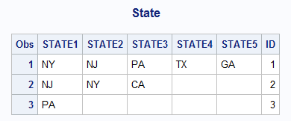

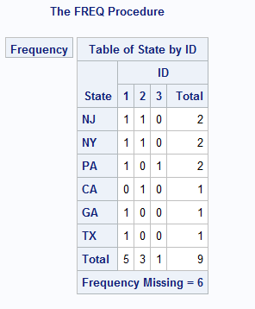

6

Code

**DATA** NEW;

SET BLAH;

ARRAY JUNK(**15**) X1-X5 Y1-Y5 Z1-Z5;

DO J=**1** to **15**;

IF JUNK = **999** THEN JUNK = **.**;

END;

DROP J;

**RUN**;

7

Code

libname college 'C:\Users\Samil\Desktop\Sem 1\Stats for programming\SAS 9.4';

**data** college.hockey1;

infile "C:\Users\Samil\Desktop\Sem 1\Stats for programming\SAS 9.4\hockey.csv" firstobs=**2** dsd;

input Date :mmddyy10. Team : $18. City : $17. State : $13. OSU OPP;

**run**;

/*proc print data=college.hockey1;

run;*/

**data** hockeymod1;

set college.hockey1;

format date mmddyy8.;

*retain W L T;

if Team='Boston College' then

do

OPP=**5**;

OSU=**2**;

end;

do;

if OSU>OPP then W+**1**;

else if OSU<OPP then L+**1**;

else T+**1**;

end;

**run**;

Title 'Hockey';

**proc** **print** data=hockeymod1;

**run**;

Title;

Log File

376 libname college 'C:\Users\Samil\Desktop\Sem 1\Stats for programming\SAS 9.4';

NOTE: Libref COLLEGE was successfully assigned as follows:

Engine: V9

Physical Name: C:\Users\Samil\Desktop\Sem 1\Stats for programming\SAS 9.4

377 data college.hockey1;

378 infile "C:\Users\Samil\Desktop\Sem 1\Stats for programming\SAS 9.4\hockey.csv" firstobs=2

378! dsd;

379 input Date :mmddyy10. Team : $18. City : $17. State : $13. OSU OPP;

380 run;

NOTE: The infile "C:\Users\Samil\Desktop\Sem 1\Stats for programming\SAS 9.4\hockey.csv" is:

Filename=C:\Users\Samil\Desktop\Sem 1\Stats for programming\SAS 9.4\hockey.csv,

RECFM=V,LRECL=32767,File Size (bytes)=1701,

Last Modified=12 September 2017 22:38:14,

Create Time=13 September 2017 18:40:35

NOTE: 36 records were read from the infile "C:\Users\Samil\Desktop\Sem 1\Stats for

programming\SAS 9.4\hockey.csv".

The minimum record length was 35.

The maximum record length was 56.

NOTE: The data set COLLEGE.HOCKEY1 has 36 observations and 6 variables.

NOTE: DATA statement used (Total process time):

real time 0.04 seconds

cpu time 0.01 seconds

381

382

383 /*proc print data=college.hockey1;

384 run;*/

385

386 data hockeymod1;

387 set college.hockey1;

388 format date mmddyy8.;

389 *retain W L T;

390 if Team='Boston College' then

391 do

392 OPP=5;

393 OSU=2;

394 end;

395 do;

396 if OSU>OPP then W+1;

397 else if OSU<OPP then L+1;

398 else T+1;

399 end;

400 run;

NOTE: There were 36 observations read from the data set COLLEGE.HOCKEY1.

NOTE: The data set WORK.HOCKEYMOD1 has 36 observations and 9 variables.

NOTE: DATA statement used (Total process time):

real time 0.03 seconds

cpu time 0.03 seconds

401

402 Title 'Hockey';

403

404 proc print data=hockeymod1;

405 run;

NOTE: There were 36 observations read from the data set WORK.HOCKEYMOD1.

NOTE: PROCEDURE PRINT used (Total process time):

real time 0.11 seconds

cpu time 0.03 seconds

406

407 Title;

Output

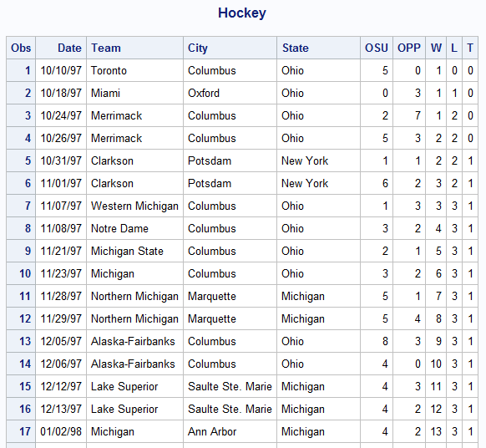

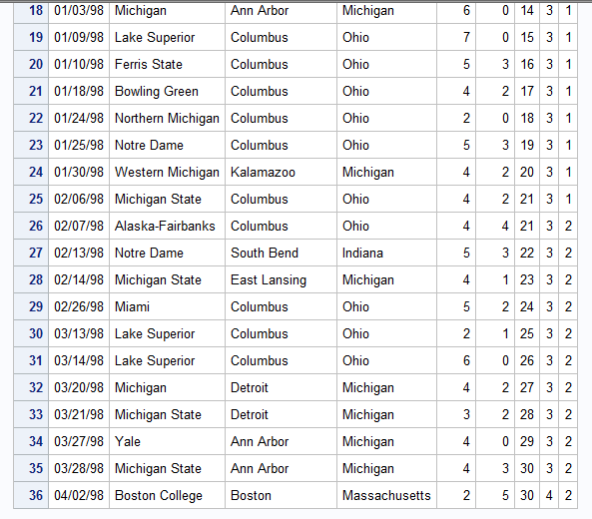

8

Code

**data** college.dog3;

infile 'C:\Users\Samil\Desktop\Sem 1\Stats for programming\SAS 9.4\dogs3.txt' firstobs=**3**;

input Name $ Week_0 Week_2 Week_4;

**run**;

Title 'Dogs3' ;

**proc** **print** data=college.dog3;

**run**;

Title;

**proc** **sort** data=college.dog3

out=dog;

by name;

**run**;

**data** dogs3;

set dog;

by name;

array eos(**3**) week_0 week_2 week_4;

do i=**1** to **3**;

week=i;

eos_count=eos(i);

output;

end;

keep name week eos_count;

**run**;

Title 'Dogs';

**proc** **print** data=dogs3;

**run**;

Title;

Log File

503 data college.dog3;

504 infile 'C:\Users\Samil\Desktop\Sem 1\Stats for programming\SAS 9.4\dogs3.txt' firstobs=3;

505 input Name $ Week_0 Week_2 Week_4;

506 run;

NOTE: The infile 'C:\Users\Samil\Desktop\Sem 1\Stats for programming\SAS 9.4\dogs3.txt' is:

Filename=C:\Users\Samil\Desktop\Sem 1\Stats for programming\SAS 9.4\dogs3.txt,

RECFM=V,LRECL=32767,File Size (bytes)=918,

Last Modified=04 October 2017 15:37:25,

Create Time=04 October 2017 15:37:25

NOTE: 25 records were read from the infile 'C:\Users\Samil\Desktop\Sem 1\Stats for

programming\SAS 9.4\dogs3.txt'.

The minimum record length was 32.

The maximum record length was 32.

NOTE: The data set COLLEGE.DOG3 has 25 observations and 4 variables.

NOTE: DATA statement used (Total process time):

real time 0.02 seconds

cpu time 0.01 seconds

507

508 Title 'Dogs3' ;

509

510 proc print data=college.dog3;

511 run;

NOTE: There were 25 observations read from the data set COLLEGE.DOG3.

NOTE: PROCEDURE PRINT used (Total process time):

real time 0.11 seconds

cpu time 0.03 seconds

512

513 Title;

514

515 proc sort data=college.dog3

516 out=dog;

517 by name;

518 run;

NOTE: There were 25 observations read from the data set COLLEGE.DOG3.

NOTE: The data set WORK.DOG has 25 observations and 4 variables.

NOTE: PROCEDURE SORT used (Total process time):

real time 0.04 seconds

cpu time 0.01 seconds

519

520 data dogs3;

521 set dog;

522 by name;

523 array eos(3) week_0 week_2 week_4;

524 do i=1 to 3;

525 week=i;

526 eos_count=eos(i);

527 output;

528 end;

529 keep name week eos_count;

530 run;

NOTE: There were 25 observations read from the data set WORK.DOG.

NOTE: The data set WORK.DOGS3 has 75 observations and 3 variables.

NOTE: DATA statement used (Total process time):

real time 0.04 seconds

cpu time 0.03 seconds

531

532 Title 'Dogs';

533

534 proc print data=dogs3;

535 run;

NOTE: There were 75 observations read from the data set WORK.DOGS3.

NOTE: PROCEDURE PRINT used (Total process time):

real time 0.13 seconds

cpu time 0.07 seconds

536

537 Title;

Output

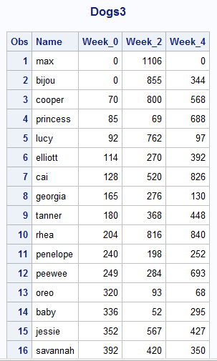

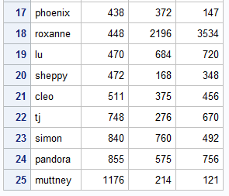

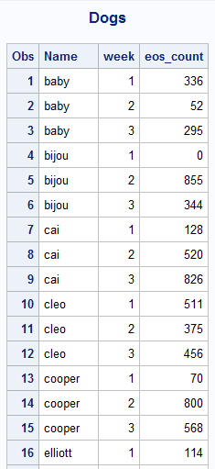

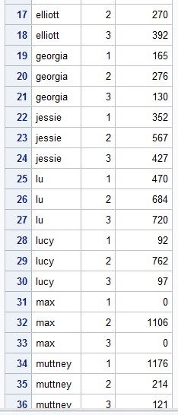

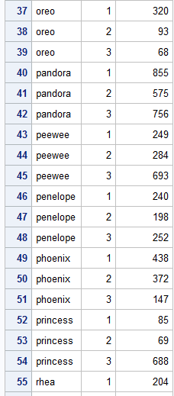

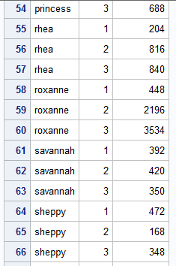

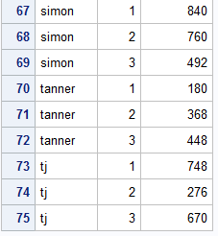

9

Code

libname college 'C:\Users\Samil\Desktop\Sem 1\Stats for programming\SAS 9.4';

**proc** **print** data=college.ryan;

**run**;

**data** Ryan2;

set college.ryan;

array m(**3**) roger nytimes usat;

do i=**1** to **3**;

if missing(m(i)) then m(i)=**5**;

end;

drop i;

**run**;

Title 'Ryan2';

**proc** **print** data=Ryan2;

**run**;

Title;

Log File

538 data Ryan2;

539 set college.ryan;

540 array m(3) roger nytimes usat;

541 do i=1 to 3;

542 if missing(m(i)) then m(i)=5;

543 end;

544 drop i;

545 run;

NOTE: There were 21 observations read from the data set COLLEGE.RYAN.

NOTE: The data set WORK.RYAN2 has 21 observations and 4 variables.

NOTE: DATA statement used (Total process time):

real time 0.02 seconds

cpu time 0.01 seconds

546

547 Title 'Ryan2';

548

549 proc print data=Ryan2;

550 run;

NOTE: There were 21 observations read from the data set WORK.RYAN2.

NOTE: PROCEDURE PRINT used (Total process time):

real time 0.12 seconds

cpu time 0.01 seconds

551

552 Title;

Output

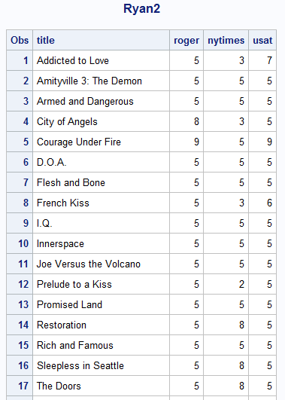

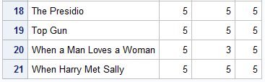

10

Code

**data** score;

input ID $ TEST_1 TEST_2 TEST_3 TEST_4 TEST_5;

datalines;

001 90 88 92 95 90

002 64 64 77 72 71

003 68 69 80 75 70

004 88 77 66 77 67

**run**;

/*proc print data=score;

run;*/

**data** score1;

set score;

array test_array(**5**) TEST_1-TEST_5;

/*Temp array is used*/

array key(**5**) _temporary_ (**65**, **70**, **60**, **62**, **68**);

Passed = **0**;

do test=**1** to **5**;

Passed + (test_array{test} > key{test});

drop test;

end;

**run**;

Title 'Scorecard';

**proc** **print** data=score1;

**run**;

Title;

Log File

176 data score;

177 input ID $ TEST_1 TEST_2 TEST_3 TEST_4 TEST_5;

178 datalines;

NOTE: The data set WORK.SCORE has 4 observations and 6 variables.

NOTE: DATA statement used (Total process time):

real time 0.01 seconds

cpu time 0.01 seconds

183 run;

184

185 /*proc print data=score;

186 run;*/

187

188 data score1;

189 set score;

190 array test_array(5) TEST_1-TEST_5;

191 /*Temp array is used*/

192 array key(5) _temporary_ (65, 70, 60, 62, 68);

193 Passed = 0;

194 do test=1 to 5;

195 Passed + (test_array{test} > key{test});

196 drop test;

197 end;

198 run;

NOTE: There were 4 observations read from the data set WORK.SCORE.

NOTE: The data set WORK.SCORE1 has 4 observations and 7 variables.

NOTE: DATA statement used (Total process time):

real time 0.01 seconds

cpu time 0.00 seconds

199

200 Title 'Scorecard';

201

202 proc print data=score1;

203 run;

NOTE: There were 4 observations read from the data set WORK.SCORE1.

NOTE: PROCEDURE PRINT used (Total process time):

real time 0.37 seconds

cpu time 0.01 seconds

204

205 Title;

Output

